**SERVERLESS IOT DATA PROCESSING IN CLOUD COMPUTING**

**Name** :M.Tharshineeswari suki

**College code** : 9530

**College name** : St.Mother Theresa Engineering college

**Naan-mudhalvan id** : au953021104053

**Team- id :** Proj_201055_Team_1



**INTRODUCTION :**

Application have gained massive popularity in recent times. IoT network computer smart and connected objects called “things”. Things communicate with Each other without any human intervention and generate a significant amount of data. Things are heterogeneous and build a dynamic infrastructure. IoT devices have already outreached the human population and are expected to cross the number of 500 billion by 2030. IoT devices differ in architecture sensing capabilities and other aspects such as memory and power. IoT Network is dynamic as devices are deployed in a frequently changing environment. Furthermore, IoT devices are resources constrained as they are often Deployed with limited memory, power and processing capability.

Cloud computing is a model where computing services such as storage, compute servers and database are provided to end users over the Internet by cloud providers. Users are charged per usage for availing these services. This billing model is similar to utilities such as electricity, gas, and water. Cloud computing not only significantly reduced the potential investment for the users but has also reduced the time to accessing a structure and services. IoT network is dynamic as devices are deployed in a frequently changing environment. Furthermore, IoT devices are resources constrained as they are often deployed with limited memory, power and processing capability.

**Problem Statement:**

Cloud computing and IoT devices are characterized by contrasting characteristics .For instance, IoT devices work with limited capabilities whereas the cloud provides an illusion of infinite resources. Cloud computing provides the required resources to the IoT network. Due to the limitations of IoT devices, generated data is offloaded to cloud-based resources for further processing, and the cloud sends the results back upon processing the data.

IoT devices in conjunction with cloud resources perform efficient data processing. However, such solution has the following limitations:

• **High latency**: Offloading a small task to the cloud scenario relativelymore time than processing it locally at the IoT device.

• **Privacy concerns**: Some tasks need more privacy, which makes it infeasible to offload their processing to the cloud.

• **Support for mobility**: In case of non-stationary sensing devices, it may be possible to offload processing data to the cloud. In such a , a sensor should be able to process it locally.

**Serverless Computing:**

Serverless computing is the latest cloud computing model specifically built for ephemeral, stateless and event-driven applications. The serverless computing model is based on on-demandhorizontal scaling approach as hosted applications are required to scale up and down instantly. It also assimilates the "pay as you go approach" of cloud computing since users are billed for the actual usage at a millisecond granularity. A more formal definition of the serverless computing is “Serverless architectures refer to applications that significantly depend on third-party services (knows as Backend as a Service or ‘BaaS’)or on custom code that’s run in ephemeral containers(Function as a Service or ‘FaaS’.)”

Serverless computing addresses present issues in cloud computing models such as relatively high setup cost, user end management, in efficient use of system resources and auto scaling. The model is designed to support minimum user management efforts and event driven architecture. The serverless logic is also known as function. Most of the available serverless projects use ephemeral containers to run these functions as a stateless service based on defined triggers and rules. Serverless functions are not limited to any specific programming language or libraries and provide flexibility of using multiple programming languages to write a function. It is also possible to wrap the function inside a container which allows the use of any possible programming language even if the serverless framework does not directly support it. A developer is only required for deploying the code to the provider’s infrastructure whereas the provider is responsible for the management, auto-scaling and execution of the function. Auto-scaling is horizontal and allows developers to handle a large burst of requests without any manual intervention.

**IBM cloud based setup:**

IBM cloud-based setup is a paid service provided by IBM cloud as IBM functions. IBM cloud function uses the only cloudant as a database. Furthermore, a command line utility is available for users to deploy, modify and execute functions. The utility for the local setup can be cloned and Installed form the Github project. IBM cloud’s command line utility also provide similar functionality and can be download from IBM cloud web pages.

OpenWhisk supports the following triggers in the IBM cloud environment.

* **Cloudant-based Trigger :-**This trigger can be defined based on any modifications made to the cloudant database.
* **Customized Trigger :-** OpenWhisk allows developers to customise the defined triggers. An example of a customised trigger is a trigger based on a POST request.
* **GitHub Trigger:-** Any changes to the Git repository can also generate an action trigger.
* **Message Hub Trigger:-** These triggers invoke an action when a new message is written to the queue.
* **Mobile Push Trigger:-** A push notification to the mobile application defines this trigger.
* **Periodic Trigger:-** Using this trigger, one can define desired date and time to execute an action.

**Methodology:**

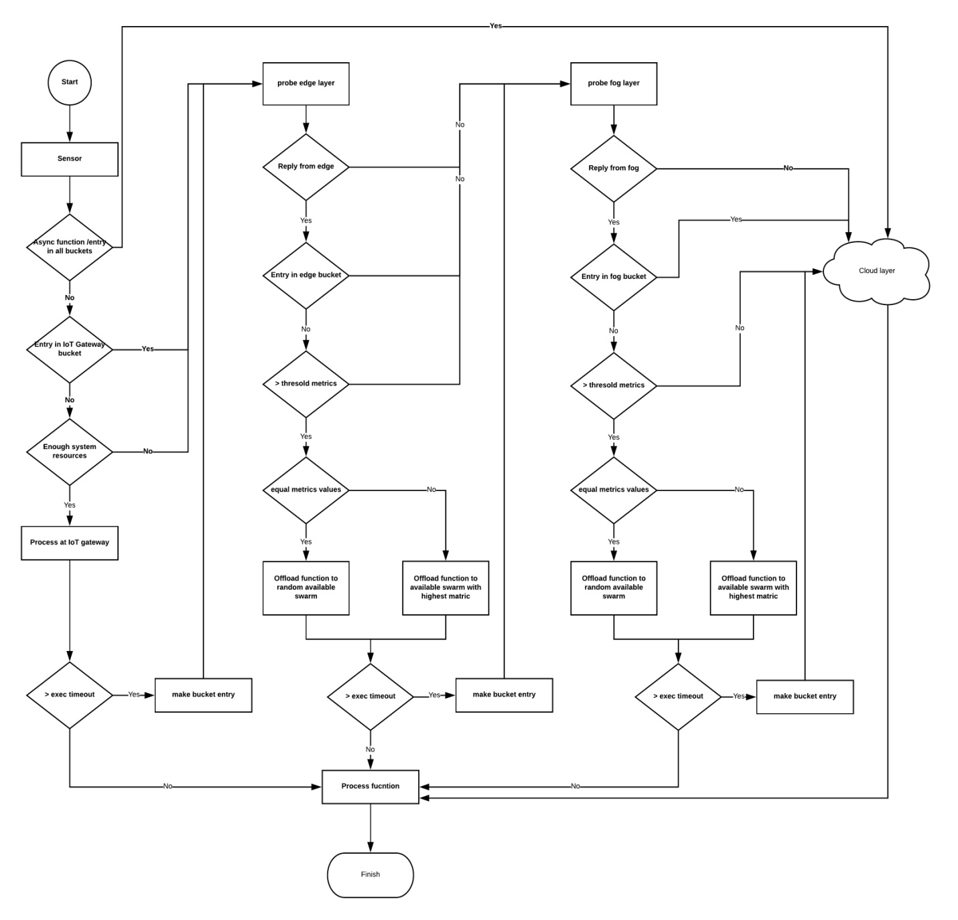

We divide the function execution offloading flow at each layer for the case of understanding.

**Offloading flow at IoT-gateway**

1. The IoT-gateway receives the data from the IoT device and triggers the function.
2. Asynchronous functions run longer than synchronous functions. IoT-Gateway offload function to cloud layer when one of the following conditions exists:
3. If the function is asynchronous.
4. If function name exists in Function bucket at each layer.
5. IoT-gateway probes function to edge layer upon encountering following Scenarios:
   1. If function name exists in the Function bucket at IoT-gateway Layer.
   2. If IoT-gateway does not have enough System resources.
6. In the case of the synchronous function and IoT-gateway has adequate system resources; it starts the execution.
7. When an OpenFaaS function execution outlives the exec timeout without giving the output, the function name is stored in the function. Bucket with the current date-time stamp. Upon making the entry, IoT-gateway probes the next layer.
8. If function finishes processing within the defined value of exec timeout, Gateway finished the function processing.

**Offloading flow at edge layer :**

* 1. IoT gateway offloads the function execution to edge layer if the edge Layer sends a multicast response in answer to the probe multicast request.
  2. The function is offloaded to the next layer if:
     + 1. Current layer remains unresponsive for a defined time limit.
       2. There is an entry of function name in Function bucket at edge layer.
       3. If the metric value is lower than the threshold.

3. In case of more than one Docker swarm:

(a) if obtained metrics are equal (equal number of active nodes), the function is randomly offloaded to one of the available nodes.

(b) else, we offload the function to the swarm with highest metric.

4. If function exceeds layer’s exec timeout, a Function bucket entry is made, and function execution is offloaded to the next layer

5. else, the function is processed at the edge layer successfully.

**Offloading flow at fog layer:**

1. Function is offloaded to the fog layer if it sends a valid multicast reply.

2. The function is offloaded to the next layer if:

(a) current layer remains unresponsive for a defined time limit.

(b) there is an entry of function name in Function bucket at fog layer.

(c) If the metric value is lower than the threshold.

3. In case of more than one Docker swarm:

(a) if obtained metrics are equal (equal number of active nodes), the function is randomly offloaded to one of the available nodes.

(b) else, we offload the function to the swarm with highest metric.

4. If function exceeds layer’s exec timeout, a Function bucket entry is made, and function execution is offloaded to the next layer

5. else, the function is processed at the fog layer successfully.

**Offloading flow at cloud layer :**

1. Upon receiving the function execution offloading, cloud layer processes

the function and returns the result.

**Software Requirements:**

To implement the solution, there are some software requirements needed. The Requirements are as follows

* Apache Open Whisk.
* IoT-Gateway.
* OpenFaas.
* Kuberless platform.

**Innovation:**

Although initially proposed for the cloud, serverless computing has also found its place on Internet of Things (IoT) while bringing functions closer to the devices, in order to reduce latency and avoid unnecessary energy and resource consumption.

**Functions Involved:**

* Apache OpenWhisk python function

import smtplib

from email.mime.multipart import MIMEMultipart

from email.mime.text import MIMEText

def main(dict):

fromaddr = ‘sender@gmail.com’

toaddr = ‘receiver@outlook.com’

msg = MIMEMultipart()

msg[‘From’] = fromaddr

msg[‘To’] = toaddr

msg[‘Subject’] = ‘Apache OpenWhisk’

body = ‘TEST’

msg.attach(MIMEText(body, ‘plain’))

server = smtplib.SMTP(‘smtp.gmail.com’, 587)

server.ehlo()

server.starttls()

server.login(fromaddr, ‘password’)

text = msg.as_string()

server.sendmail(fromaddr, toaddr, text)

return {“Status”, “Success”}

* Faas python function

import requests

import json

def handle(req):

result = {“found”: False}

json_req = json.loads(req)

r = requests.get(json_req[“url”])

if json_req[“term”] in r.text:

result = {“found”: True}

print json.dumps(result)

## Kubeless Functions

kubeless**function**deployget-python--runtime\

python2.7 --from-file \func.py--handlerfunc.foobar

## Kubeless Tiggers

apiVersion:kubeless.io/v1beta1kind:HTTPTrigger

metadata:labels:

created-by:kubelessname: get-pythonnamespace:default

spec:

**function**-name:get-python

host-name:get-python.192.168.99.100.nip.ioingress-enabled:**true**

path:functls:**false**

## Kubeless kafka triggers

apiVersion:kubeless.io/v1beta1kind:KafkaTrigger

metadata:labels:

created-by:kubeless

name:s3-python-kafka-triggernamespace:default

spec:

functionSelector:matchLabels:

created-by:kubelesstopic:s3-python

topic:s3-python

## Kubeless HTTP Triggers

apiVersion:kubeless.io/v1beta1kind:CronJobTrigger

metadata:labels:

created-by:kubeless

**function**:scheduled-get-pythonname: scheduled-get-pythonnamespace:default

spec:

**function**-name:scheduled-get-pythonschedule:’***** apiVersion:kubeless.io/v1beta1kind:CronJobTrigger

metadata:labels:

created-by:kubeless

**function**:scheduled-get-pythonname: scheduled-get-pythonnamespace:default

spec:

**function**-name:scheduled-get-pythonschedule:’*****’

## Conclusion:

This work demonstrated an implementation of serverless computing in an IoT network. We considered the resource constrained nature and heterogeneity of IoT devices in our solution. Devices with different attributes such as processing capability, memory, battery, sensors were set up in a cluster using a Docker based orchestration mechanism called Docker swarm. Our work also inherits some beneficial properties of Docker swarm such as fault-tolerance and high availability.

In particular, we constructed a multi-layered architecture for our solution with layers such as IoT-Gateway, fog, edge and cloud layer. Available open-source serverless platforms such as Apache OpenWhisk, OpenFaaS, Kube-less and Fission were surveyed. Upon careful evaluation, we selected Open-FaaS at IoT-Gateway, fog, edge layers due to its ease of deployment on armarchitecture based devices and flexibility. OpenFaaS was also preferred over Kubeless as latter can only be deployed using kubernetes. The architecture used IBM cloud functions as cloud layer due to its cost effectiveness. IBM cloud functions is an IBM proprietary version of Apache OpenWhisk.

An algorithm was designed for the function execution offloading among different layers of our architecture. The maximum function execution time was defined at each layer depending upon the resources availability. The offloading decision was made based on the availability of active nodes in the Docker swarm. Functions were written in python and deployed at each layer by using the OpenFaaS command line interface.

## The solution late revaluated on various factors such as ease of deployment, high availability, fault-tolerance, device and function heterogeneity, security and privacy. We also compare the function execution time at various layers of proposed solution. We showed that it is possible to successfully deploy as erverless platform on IoT devices and use it to perform various tasks with the help of serverless functions.

*_____________________*